Pengumpulan melalui ketua kelas mengunakan google drive:

BATASPENUMPULAN PERTEMUAN 14

MATA KULIAH: Object Oriented Programming

KELAS: TI.23.A2

NIM: 312310224

NAMA: Arya Wiratama

ABSEN: 25

Untuk pengisian absen dengan v(cek lst) di bawah pertemuan **bila anda masuk belum diabsenkan**

|  |  |  |  |  |  |  |  |  |  |  |  |  |  |  |  |
| --- | --- | --- | --- | --- | --- | --- | --- | --- | --- | --- | --- | --- | --- | --- | --- |
| **1** | **2** | **3** | **4** | **5** | **6** | **7** | **8** | **9** | **10** | **11** | **12** | **13** | **14** | **15** | **16** |
| **V** | **V** | **V** |  |  |  |  |  |  |  |  |  |  |  |  |  |

* **Laporan Tugas dan Tugas yang tertinggal**

Di ketik pertemuan ke berapa dan tentang apa programnya

(program di copy di ms.word dan hasil screen shoot

**MODUL 1**

1. **Memulai Aplikasi Netbeans**
2. **Membuat Class**

/*

* Click nbfs://nbhost/SystemFileSystem/Templates/Licenses/license-default.txt to change this license

*/

package com.mycompany.membuatclass;

/**

*

* @author wirar

*/

public class MembuatClass {

public static void main(String[] args) {

String name, address;

name = "Budi";

address = "Jl. Setia Budi Medan";

System.out.println("Nama " + name);

System.out.println("Alamat " + address);

}

}

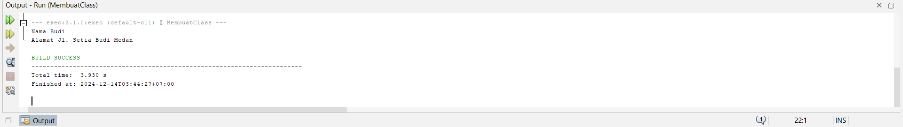

1. **Membuat Object**

/*

* Click nbfs://nbhost/SystemFileSystem/Templates/Licenses/license-default.txt to change this license

*/

package com.mycompany.membuatobject;

/**

*

* @author wirar

*/

class variable {

int lebar;

int panjang;

}

public class MembuatObject {

public static void main(String[] args) {

double luas;

variable p = new variable();

p.panjang = 20;

p.lebar = 10;

luas = p.panjang * p.lebar;

System.out.println("Luas Persegi : " + luas);

}

}

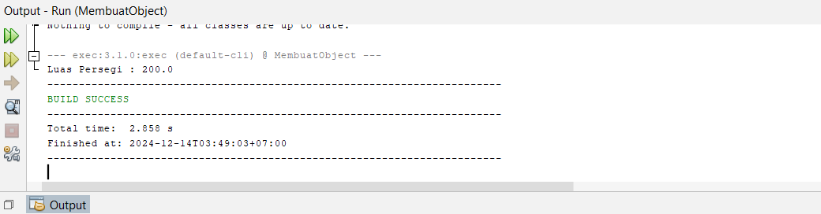

1. **Membuat Method**

/*

* Click nbfs://nbhost/SystemFileSystem/Templates/Licenses/license-default.txt to change this license

*/

package com.mycompany.membuatmethod;

/**

*

* @author wirar

*/

class kali {

double a;

double b;

void hasil() {

System.out.println("Hasil Perkalian: " + (a * b));

}

}

public class MembuatMethod {

public static void main(String[] args) {

kali variabel1, variabel2;

variabel1 = new kali();

variabel2 = new kali();

variabel1.a = 3;

variabel1.b = 6;

variabel2.a = 5;

variabel2.b = 6;

variabel1.hasil();

variabel2.hasil();

}

}

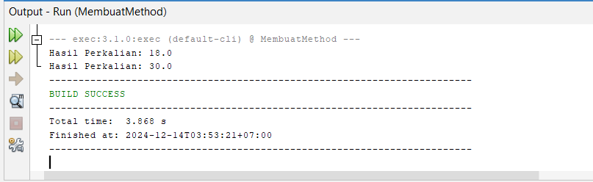

1. **Membuat Constructor**

/*

* Click nbfs://nbhost/SystemFileSystem/Templates/Licenses/license-default.txt to change this license

*/

package com.mycompany.membuatconstructor;

/**

*

* @author wirar

*/

class konstruktor{

int panjang;

int lebar;

konstruktor(){

panjang = 15;

lebar = 4;

}

int luas(){

return (panjang * lebar);

}

}

public class MembuatConstructor {

public static void main(String[] args) {

konstruktor k1,k2;

k1 = new konstruktor();

k2 = new konstruktor();

System.out.println("Luas Persegi Panjang K1 : " + k1.luas());

System.out.println("Luas Persegi Panjang K2 : " + k2.luas());

}

}

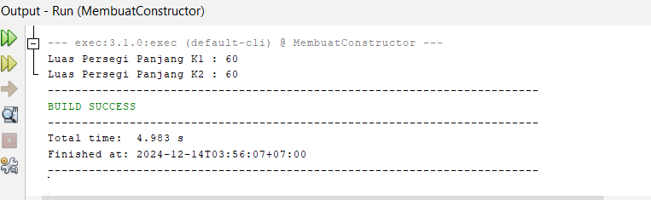

**MODUL 2**

1. **Input dengan Scanner**

/*

* Click nbfs://nbhost/SystemFileSystem/Templates/Licenses/license-default.txt to change this license

*/

package com.mycompany.inputdenganscanner;

/**

*

* @author wirar

*/

import java.util.Scanner;

public class InputDenganScanner {

public static void main(String[] args){

String nama, jurusan, fakultas, universitas;

Scanner input = new Scanner (System.in);

System.out.print("Nama : ");

nama = input.nextLine();

System.out.print("Jurusan : ");

jurusan = input.nextLine();

System.out.print("Fakultas : ");

fakultas = input.nextLine();

System.out.print("Universitas : ");

universitas = input.nextLine();

}

}

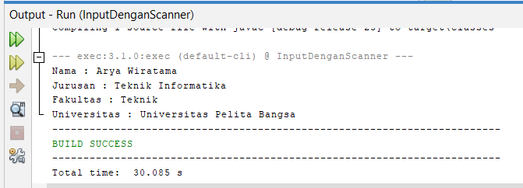

1. **Input dengan BufferedReader**

/*

* Click nbfs://nbhost/SystemFileSystem/Templates/Licenses/license-default.txt to change this license

*/

package com.mycompany.inputdenganbufferedreader;

import java.io.BufferedReader;

import java.io.IOException;

import java.io.InputStreamReader;

public class InputDenganBufferedReader {

public static void main(String[] args) throws IOException{

String nama;

InputStreamReader isr = new InputStreamReader (System.in);

BufferedReader br = new BufferedReader(isr);

System.out.print("Nama : ");

nama = br.readLine();

}

}

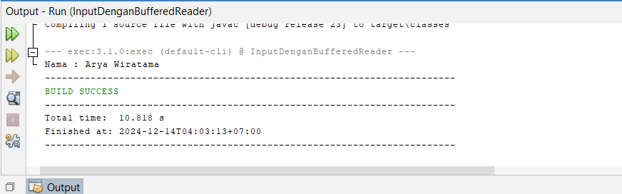

1. **Input dengan JoptionPane**

/*

* Click nbfs://nbhost/SystemFileSystem/Templates/Licenses/license-default.txt to change this license

*/

package com.mycompany.inputdenganjoptionpane;

/**

*

* @author wirar

*/

import javax.swing.JOptionPane;

public class InputDenganJOptionPane {

public static void main(String[] args) {

String nama = " ";

nama = JOptionPane.showInputDialog("Masukan nama : ");

String msg = "Selamat Belajar " + nama;

JOptionPane.showMessageDialog(null,msg);

}

}

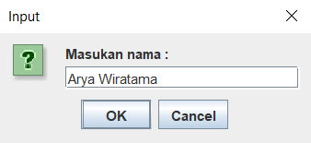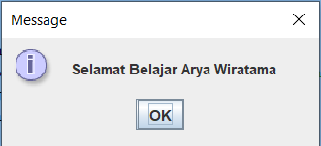

**MODUL 3**

1. IF-ELSE

/*

* Click nbfs://nbhost/SystemFileSystem/Templates/Licenses/license-default.txt to change this license

* Click nbfs://nbhost/SystemFileSystem/Templates/Classes/Class.java to edit this template

*/

package com.mycompany.test8;

/**

*

* @author wirar

*/

public class Test8 {

public static void main(String []args){

String kategori = " ";

int nilai_UAS_PBO;

nilai_UAS_PBO = 79;

if (nilai_UAS_PBO > 85){

kategori = "Anda Lulus";

}else {

kategori = "Anda tidak lulus";

}

System.out.println(kategori);

}

}

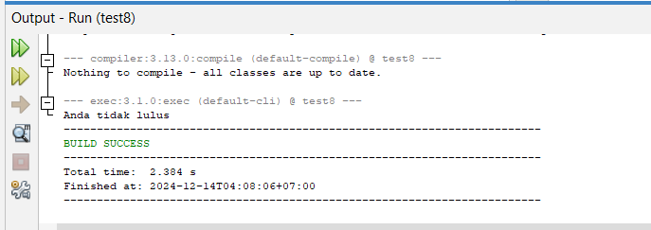

1. **Switch-Case**

/*

* Click nbfs://nbhost/SystemFileSystem/Templates/Licenses/license-default.txt to change this license

*/

package com.mycompany.test9;

/**

*

* @author wirar

*/

public class Test9 {

public static void main(String[] args) {

int pilihan;

pilihan = 3;

switch(pilihan){

case 1 :

System.out.println("Universitas Sumatera Utara");

break;

case 2 :

System.out.println("Universitas Negeri Medan");

break;

case 3 :

System.out.println("Universitas Islam Negeri Sumatera Utara");

break;

default:

System.out.println("Universitas Medan Area");

break;

}

}

}

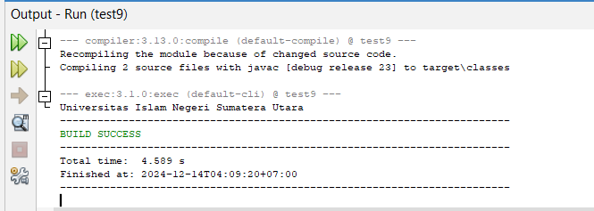

1. For-Loop

/*

* Click nbfs://nbhost/SystemFileSystem/Templates/Licenses/license-default.txt to change this license

*/

package com.mycompany.test10;

/**

*

* @author wirar

*/

public class Test10 {

public static void main(String[] args) {

for (int a = 1; a <= 20; a++){

System.out.println(a);

}

}

}

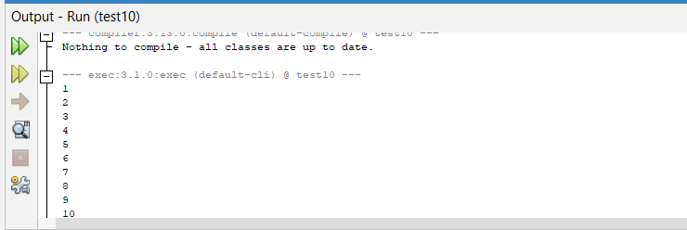

1. While-Loop

/*

* Click nbfs://nbhost/SystemFileSystem/Templates/Licenses/license-default.txt to change this license

*/

package com.mycompany.test11;

/**

*

* @author wirar

*/

public class Test11 {

public static void main(String[] args) {

int a;

a = 1;

while(a <= 15){

System.out.println(a);

a++;

}

}

}

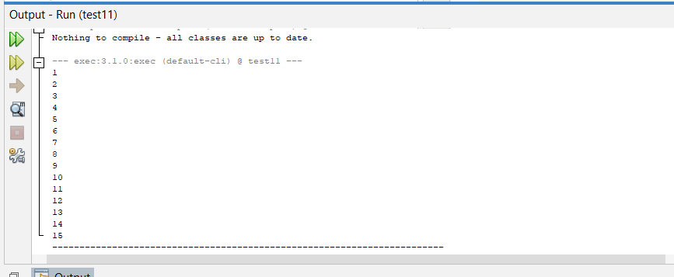

1. Do-While-Loop

/*

* Click nbfs://nbhost/SystemFileSystem/Templates/Licenses/license-default.txt to change this license

*/

package com.mycompany.test12;

/**

*

* @author wirar

*/

public class Test12 {

public static void main(String[] args) {

int a;

a = 1;

do{

System.out.println(a);

a++;

}while(a <= 10);

}

}

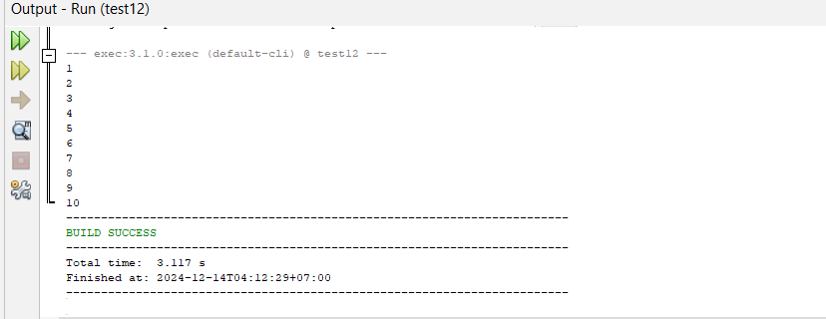

1. Break

/*

* Click nbfs://nbhost/SystemFileSystem/Templates/Licenses/license-default.txt to change this license

*/

package com.mycompany.test13;

/**

*

* @author wirar

*/

public class Test13 {

public static void main(String[] args) {

for (int a = 1; a <= 10; a++){

System.out.println("Selamat Belajar Bahasa Pemrograman Java OOP");

if (a == 5){

break;

}

}

System.out.println("Proses berhenti saat perulangan ke-5");

}

}

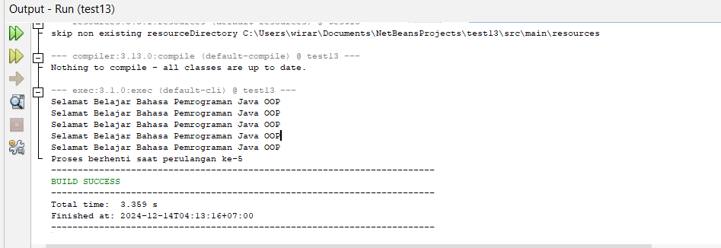

1. Continue

/*

* Click nbfs://nbhost/SystemFileSystem/Templates/Licenses/license-default.txt to change this license

*/

package com.mycompany.test14;

/**

*

* @author wirar

*/

public class Test14 {

public static void main(String[] args) {

int a;

int b;

for (a = 1; a <= 10; a++){

System.out.println("Perulangan Pertama");

a = a + 1;

if (a == 5){

continue;

}

}

System.out.println("Terjadi penghentian dan dilanjutkan ke");

for (b = 1; b < 3; b++){

System.out.println("Perulangan kedua");

}

}

}

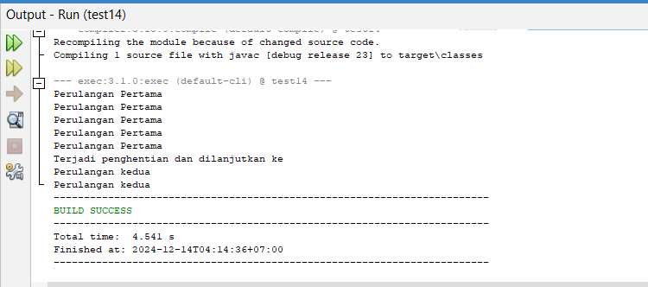

**ARRAY (LARIK)**

1. **Pengaksesan Elemen Array**

/*

* Click nbfs://nbhost/SystemFileSystem/Templates/Licenses/license-default.txt to change this license

*/

package com.mycompany.arraysample;

/**

*

* @author wirar

*/

public class ArraySample {

public static void main(String[] args) {

int[] ages = new int[100];

for (int i = 0; i < 100; i++){

System.out.print(ages[i]);

}

}

}

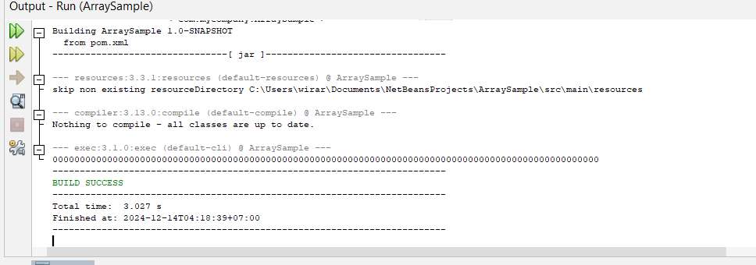

1. **Panjang Array**

/*

* Click nbfs://nbhost/SystemFileSystem/Templates/Licenses/license-default.txt to change this license

*/

package com.mycompany.arraysampledua;

/**

*

* @author wirar

*/

public class ArraySampleDua {

public static void main(String[] args) {

int[] ages = new int[100];

for (int i = 0; i < ages.length; i++){

System.out.print(ages[i]);

}

}

}

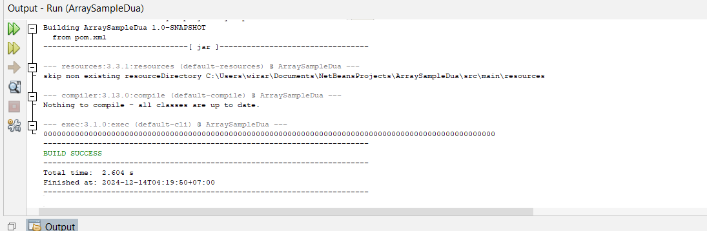

1. Array MultiDimensi

/*

* Click nbfs://nbhost/SystemFileSystem/Templates/Licenses/license-default.txt to change this license

*/

package com.mycompany.contoh2d;

/**

*

* @author wirar

*/

public class Contoh2D {

int A [][] = {{3,7,5},{2,8,6}};

public void cetak(){

System.out.println(" Matriks A ");

for (int i = 0; i < A.length; i++){

for (int j = 0; j < A[0].length; j++){

System.out.print(A[i][j] + " ");

}

System.out.println();

}

}

public static void main(String[] args) {

Contoh2D jm = new Contoh2D();

jm.cetak();

}

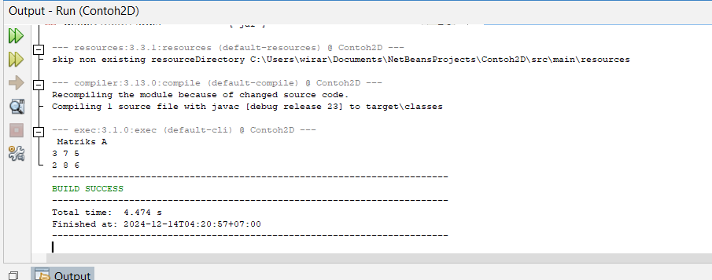

**MODUL 4**

1. StudentRecord

/*

* Click nbfs://nbhost/SystemFileSystem/Templates/Licenses/license-default.txt to change this license

*/

package com.mycompany.studentrecord;

/**

*

* @author wirar

*/

public class StudentRecord {

private String name;

private String address;

private int age;

private double mathGrade;

private double englishGrade;

private double scienceGrade;

private double average;

private static int studentCount;

public String getName(){

return name;

}

public void setName(String temp) {

name = temp;

}

public double getAverage(){

double result = 0;

result = (mathGrade+englishGrade+scienceGrade) / 3;

return result;

}

public static int getStudentCount(){

return studentCount;

}

public static void main(String[] args) {

StudentRecord annaRecord = new StudentRecord();

StudentRecord beahRecord = new StudentRecord();

StudentRecord crisRecord = new StudentRecord();

annaRecord.setName("Anna");

beahRecord.setName("Beah");

crisRecord.setName("Cris");

System.out.println(annaRecord.getName());

System.out.println("Count=" + StudentRecord.getStudentCount());

}

}

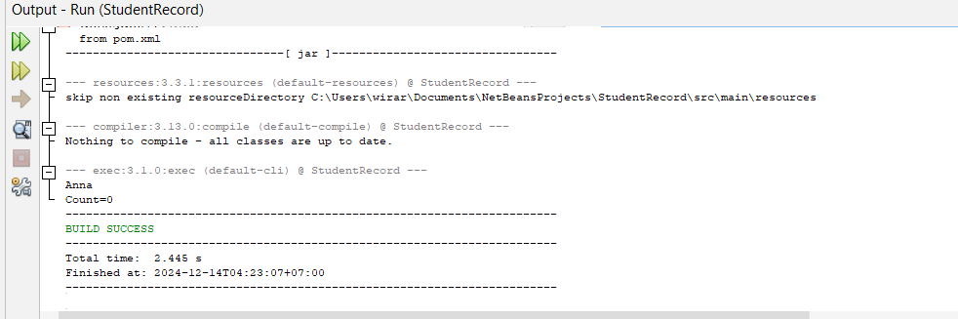

1. OverLoading Method

package com.mycompany.studentrecord2;

/**

* Student Record System

* Author: Arya Wiratama;

*/

public class StudentRecord2 {

private String name;

private String address;

private int age;

private double mathGrade;

private double englishGrade;

private double scienceGrade;

public void setName(String temp) {

name = temp;

}

public String getName() {

return name;

}

public void setAddress(String temp) {

address = temp;

}

public String getAddress() {

return address;

}

public void setAge(int temp) {

age = temp;

}

public int getAge() {

return age;

}

public void setMathGrade(double temp) {

mathGrade = temp;

}

public double getMathGrade() {

return mathGrade;

}

public void setEnglishGrade(double temp) {

englishGrade = temp;

}

public double getEnglishGrade() {

return englishGrade;

}

public void setScienceGrade(double temp) {

scienceGrade = temp;

}

public double getScienceGrade() {

return scienceGrade;

}

public double getAverage() {

return (mathGrade + englishGrade + scienceGrade) / 3;

}

public void printStudentInfo() {

System.out.println("Name: " + name);

System.out.println("Address: " + address);

System.out.println("Age: " + age);

}

public void printGrades() {

System.out.println("Math Grade: " + mathGrade);

System.out.println("English Grade: " + englishGrade);

System.out.println("Science Grade: " + scienceGrade);

}

public void printAverage() {

System.out.println("Average Grade: " + getAverage());

}

public static void main(String[] args) {

StudentRecord2 student = new StudentRecord2();

student.setName("Arya Wiratama");

student.setAddress("Kalijaya");

student.setAge(16);

student.setMathGrade(85.5);

student.setEnglishGrade(90.0);

student.setScienceGrade(88.0);

System.out.println("=== Student Information ===");

student.printStudentInfo();

System.out.println();

System.out.println("=== Student Grades ===");

student.printGrades();

System.out.println();

System.out.println("=== Average Grade ===");

student.printAverage();

}

}

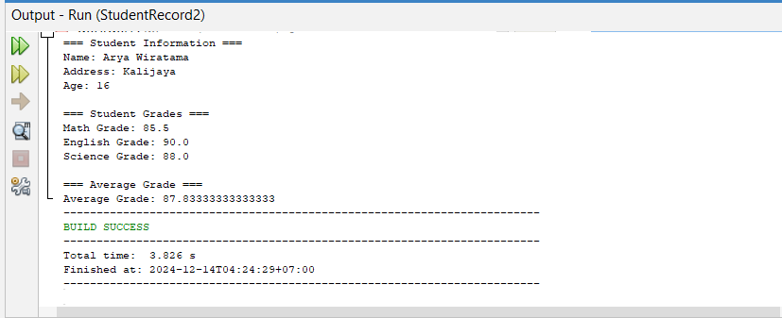

1. **Overloading Constructor**

/*

* Click nbfs://nbhost/SystemFileSystem/Templates/Licenses/license-default.txt to change this license

*/

package com.mycompany.cobaoverloadingmethod;

/**

*

* @author wirar

*/

class CobaOverloadingMethod {

private int stuID;

private String stuName;

private int stuAge;

// Default constructor

CobaOverloadingMethod() {

stuID = 100;

stuName = "New Student";

stuAge = 18;

}

CobaOverloadingMethod(int num1, String str, int num2) {

stuID = num1;

stuName = str;

stuAge = num2;

}

public int getStuID() {

return stuID;

}

public void setStuID(int stuID) {

this.stuID = stuID;

}

public String getStuName() {

return stuName;

}

public void setStuName(String stuName) {

this.stuName = stuName;

}

public int getStuAge() {

return stuAge;

}

public void setStuAge(int stuAge) {

this.stuAge = stuAge;

}

public static void main(String[] args) {

CobaOverloadingMethod data1 = new CobaOverloadingMethod();

System.out.println("Student Name is: " + data1.getStuName());

System.out.println("Student Age is: " + data1.getStuAge());

System.out.println("Student ID is: " + data1.getStuID());

CobaOverloadingMethod data2 = new CobaOverloadingMethod(555, "Chaitanya", 25);

System.out.println("Student Name is: " + data2.getStuName());

System.out.println("Student Age is: " + data2.getStuAge());

System.out.println("Student ID is: " + data2.getStuID());

}

}

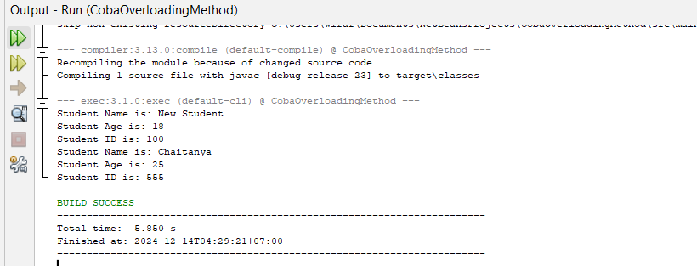

ENCAPSULATION

/*

* Click nbfs://nbhost/SystemFileSystem/Templates/Licenses/license-default.txt to change this license

*/

package com.mycompany.main;

/**

*

* @author wirar

*/

// Class representing a person

class Person {

// Private fields

private String name;

private int age;

// Constructor to initialize the fields

public Person(String name, int age) {

this.name = name;

this.age = age;

}

// Getter for name

public String getName() {

return name;

}

// Setter for name

public void setName(String name) {

this.name = name;

}

// Getter for age

public int getAge() {

return age;

}

// Setter for age

public void setAge(int age) {

// Check to ensure the age is positive

if (age > 0) {

this.age = age;

} else {

System.out.println("Age must be positive.");

}

}

// Method to display person information

public void displayInfo() {

System.out.println("Name: " + name);

System.out.println("Age: " + age);

}

}

public class Main {

public static void main(String[] args) {

// Creating an object of Person class

Person person = new Person("John", 25);

// Accessing and modifying the data using getters and setters

person.displayInfo(); // Display the initial information

// Changing the name and age using setter methods

person.setName("Alice");

person.setAge(30);

// Display updated information

person.displayInfo();

}

}

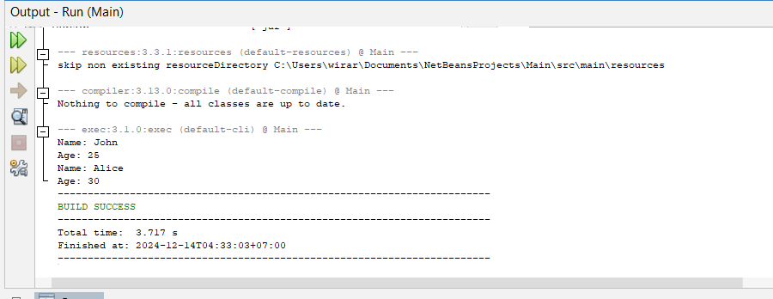

**MethodExample**

/*

* Click nbfs://nbhost/SystemFileSystem/Templates/Licenses/license-default.txt to change this license

*/

package com.mycompany.methodexample;

/**

*

* @author wirar

*/

public class MethodExample {

public int add(int a, int b) {

return a + b;

}

public void greet(String name) {

System.out.println("Hello, " + name + "!");

}

public static double calculateArea(double radius) {

return Math.PI * radius * radius;

}

public static void main(String[] args) {

MethodExample example = new MethodExample();

int sum = example.add(5, 7);

System.out.println("Sum of 5 and 7: " + sum);

example.greet("Alice");

double area = MethodExample.calculateArea(5.0);

System.out.println("Area of circle with radius 5.0: " + area);

}

}

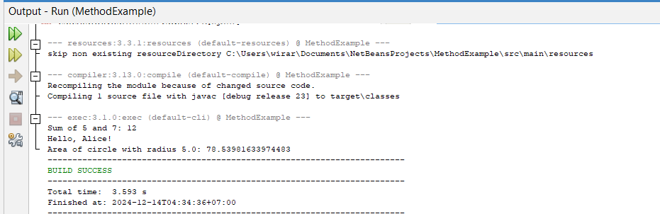

**UTS**

/*

* Click nbfs://nbhost/SystemFileSystem/Templates/Licenses/license-default.txt to change this license

*/

package com.mycompany.utsoop;

import java.util.Scanner;

/**

*

* @author wirar

*/

public class UTSOOP {

public static void main(String[] args) {

String isDone;

Scanner scanner = new Scanner(System.in);

while (true){

System.out.println("============================================");

System.out.println(" Isi Data Pasien ");

System.out.println("============================================");

String nama, jenis_kelamin;

int no_pasien, usia, tinggi_badan, berat_badan;

System.out.print("No Pasien : ");

no_pasien = scanner.nextInt();

scanner.nextLine();

System.out.print("Nama : ");

nama = scanner.nextLine();

System.out.print("Usia : ");

usia = scanner.nextInt();

scanner.nextLine();

System.out.print("Jenis Kelamin (L/P) : ");

jenis_kelamin = scanner.nextLine();

System.out.print("Tinggi Badan : ");

tinggi_badan = scanner.nextInt();

System.out.print("Berat Badan : ");

berat_badan = scanner.nextInt();

scanner.nextLine();

System.out.println("============================================");

System.out.println(" Data Pasien ");

System.out.println("============================================");

System.out.println("No Pasien: " + no_pasien);

System.out.println("Nama: " + nama);

System.out.println("Usia: " + usia);

System.out.println("Jenis Kelamin: " + jenis_kelamin);

System.out.println("Tinggi Badan: " + tinggi_badan);

System.out.println("Berat Badan: " + berat_badan);

System.out.print("Apakah Ingin Isi Data Pasien Lagi (y/n) ? ");

isDone = scanner.nextLine();

if (isDone.equalsIgnoreCase("n")){

break;

}

}

System.out.println("Program Selesai");

scanner.close();

}

}

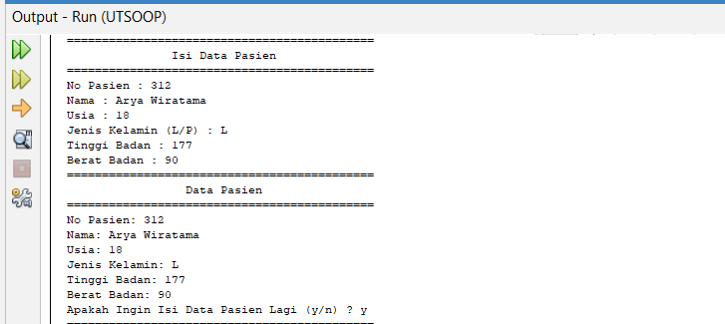

**TugasKelompokAryaDanFarel**

/*

* Click nbfs://nbhost/SystemFileSystem/Templates/Licenses/license-default.txt to change this license

*/

package com.mycompany.tugaskelaryadanfarelpewarisan;

/**

*

* @author wirar

*/

class SmartPhone {

String nama;

int harga;

String warna;

public SmartPhone(String nama, int harga, String warna) {

this.nama = nama;

this.harga = harga;

this.warna = warna;

}

public void fastCharging() {

System.out.println(this.nama + " mengisi daya dengan cepat");

}

}

class Android extends SmartPhone {

public Android(String nama, int harga, String warna) {

super(nama, harga, warna);

}

public void belahLayar() {

System.out.println(this.nama + " memiliki layar yang dapat dibelah");

}

}

class Iphone extends SmartPhone {

public Iphone(String nama, int harga, String warna) {

super(nama, harga, warna);

}

public void airDrop() {

System.out.println(this.nama + " melakukan airdrop ke handphone lain");

}

}

public class TugasKelAryaDanFarelPewarisan {

public static void main(String[] args) {

Android xiaomiNote9 = new Android("Xiaomi Note 9", 5000000, "Hitam");

xiaomiNote9.fastCharging();

xiaomiNote9.belahLayar();

Iphone iphone14 = new Iphone("Iphone 14", 14000000, "Merah");

iphone14.fastCharging();

iphone14.airDrop();

}

}

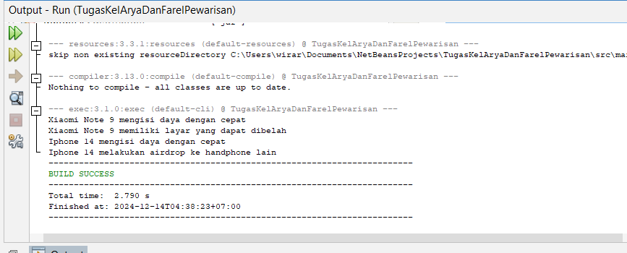

**Pertemuan 14**

Main.java:  
  
/*

* Click nbfs://nbhost/SystemFileSystem/Templates/Licenses/license-default.txt to change this license

* Click nbfs://nbhost/SystemFileSystem/Templates/Other/File.java to edit this template

*/

package com.mycompany.buku;

/**

*

* @author wirar

*/

import java.util.Scanner;

public class Main {

public static void main(String[] args) {

Scanner scanner = new Scanner(System.in);

KoleksiBuku koleksiBuku = new KoleksiBuku();

while (true) {

System.out.println("=== Aplikasi Koleksi Buku ===");

System.out.println("1. Tambah Buku");

System.out.println("2. Hapus Buku");

System.out.println("3. Tampilkan Semua Buku");

System.out.println("4. Cari Buku");

System.out.println("5. Keluar");

System.out.print("Pilih menu (1-5): ");

int pilihan = scanner.nextInt();

scanner.nextLine(); // Menangkap newline setelah input integer

switch (pilihan) {

case 1:

System.out.print("Masukkan judul buku: ");

String judul = scanner.nextLine();

System.out.print("Masukkan pengarang buku: ");

String pengarang = scanner.nextLine();

System.out.print("Masukkan tahun terbit buku: ");

int tahunTerbit = scanner.nextInt();

scanner.nextLine(); // Menangkap newline setelah input integer

Buku bukuBaru = new Buku(judul, pengarang, tahunTerbit);

koleksiBuku.tambahBuku(bukuBaru);

System.out.println("Buku telah ditambahkan.");

break;

case 2:

System.out.print("Masukkan judul buku yang ingin dihapus: ");

String judulHapus = scanner.nextLine();

koleksiBuku.hapusBuku(judulHapus);

break;

case 3:

koleksiBuku.tampilkanSemuaBuku();

break;

case 4:

System.out.print("Masukkan judul buku yang ingin dicari: ");

String judulCari = scanner.nextLine();

koleksiBuku.cariBuku(judulCari);

break;

case 5:

System.out.println("Terima kasih!");

scanner.close();

return;

default:

System.out.println("Pilihan tidak valid. Silakan coba lagi.");

}

}

}

}

Buku.java:  
  
**/\***

* Click nbfs://nbhost/SystemFileSystem/Templates/Licenses/license-default.txt to change this license

*/

package com.mycompany.buku;

/**

*

* @author wirar

*/

public class Buku {

private String judul;

private String pengarang;

private int tahunTerbit;

// Konstruktor

public Buku(String judul, String pengarang, int tahunTerbit) {

this.judul = judul;

this.pengarang = pengarang;

this.tahunTerbit = tahunTerbit;

}

// Getter dan Setter

public String getJudul() {

return judul;

}

public void setJudul(String judul) {

this.judul = judul;

}

public String getPengarang() {

return pengarang;

}

public void setPengarang(String pengarang) {

this.pengarang = pengarang;

}

public int getTahunTerbit() {

return tahunTerbit;

}

public void setTahunTerbit(int tahunTerbit) {

this.tahunTerbit = tahunTerbit;

}

// Menampilkan informasi buku

public void tampilkanInfo() {

System.out.println("Judul: " + judul);

System.out.println("Pengarang: " + pengarang);

System.out.println("Tahun Terbit: " + tahunTerbit);

System.out.println("----------------------------------");

}

}

KoleksiBuku.java:  
  
/*

* Click nbfs://nbhost/SystemFileSystem/Templates/Licenses/license-default.txt to change this license

* Click nbfs://nbhost/SystemFileSystem/Templates/Other/File.java to edit this template

*/

package com.mycompany.buku;

/**

*

* @author wirar

*/

import java.util.ArrayList;

public class KoleksiBuku {

private ArrayList<Buku> koleksi;

// Konstruktor

public KoleksiBuku() {

koleksi = new ArrayList<>();

}

// Menambahkan buku ke koleksi

public void tambahBuku(Buku buku) {

koleksi.add(buku);

}

// Menghapus buku dari koleksi berdasarkan judul

public void hapusBuku(String judul) {

for (int i = 0; i < koleksi.size(); i++) {

if (koleksi.get(i).getJudul().equalsIgnoreCase(judul)) {

koleksi.remove(i);

System.out.println("Buku '" + judul + "' telah dihapus.");

return;

}

}

System.out.println("Buku dengan judul '" + judul + "' tidak ditemukan.");

}

// Menampilkan semua buku dalam koleksi

public void tampilkanSemuaBuku() {

if (koleksi.isEmpty()) {

System.out.println("Koleksi buku kosong.");

} else {

for (Buku buku : koleksi) {

buku.tampilkanInfo();

}

}

}

// Mencari buku berdasarkan judul

public void cariBuku(String judul) {

for (Buku buku : koleksi) {

if (buku.getJudul().equalsIgnoreCase(judul)) {

buku.tampilkanInfo();

return;

}

}

System.out.println("Buku dengan judul '" + judul + "' tidak ditemukan.");

}

}

Output:  
  
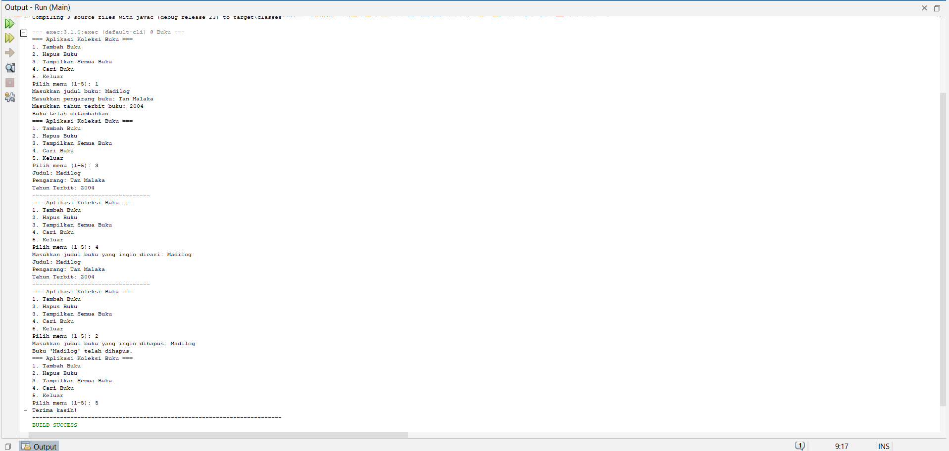

**Dosen Pengampu,**



**Ismasari Nawangsih, S.Kom., M. Kom**